Billing accounts creation in GCP

Limitations :- No limitations

Possibilities 1 :- One billing account can map one or more projects //

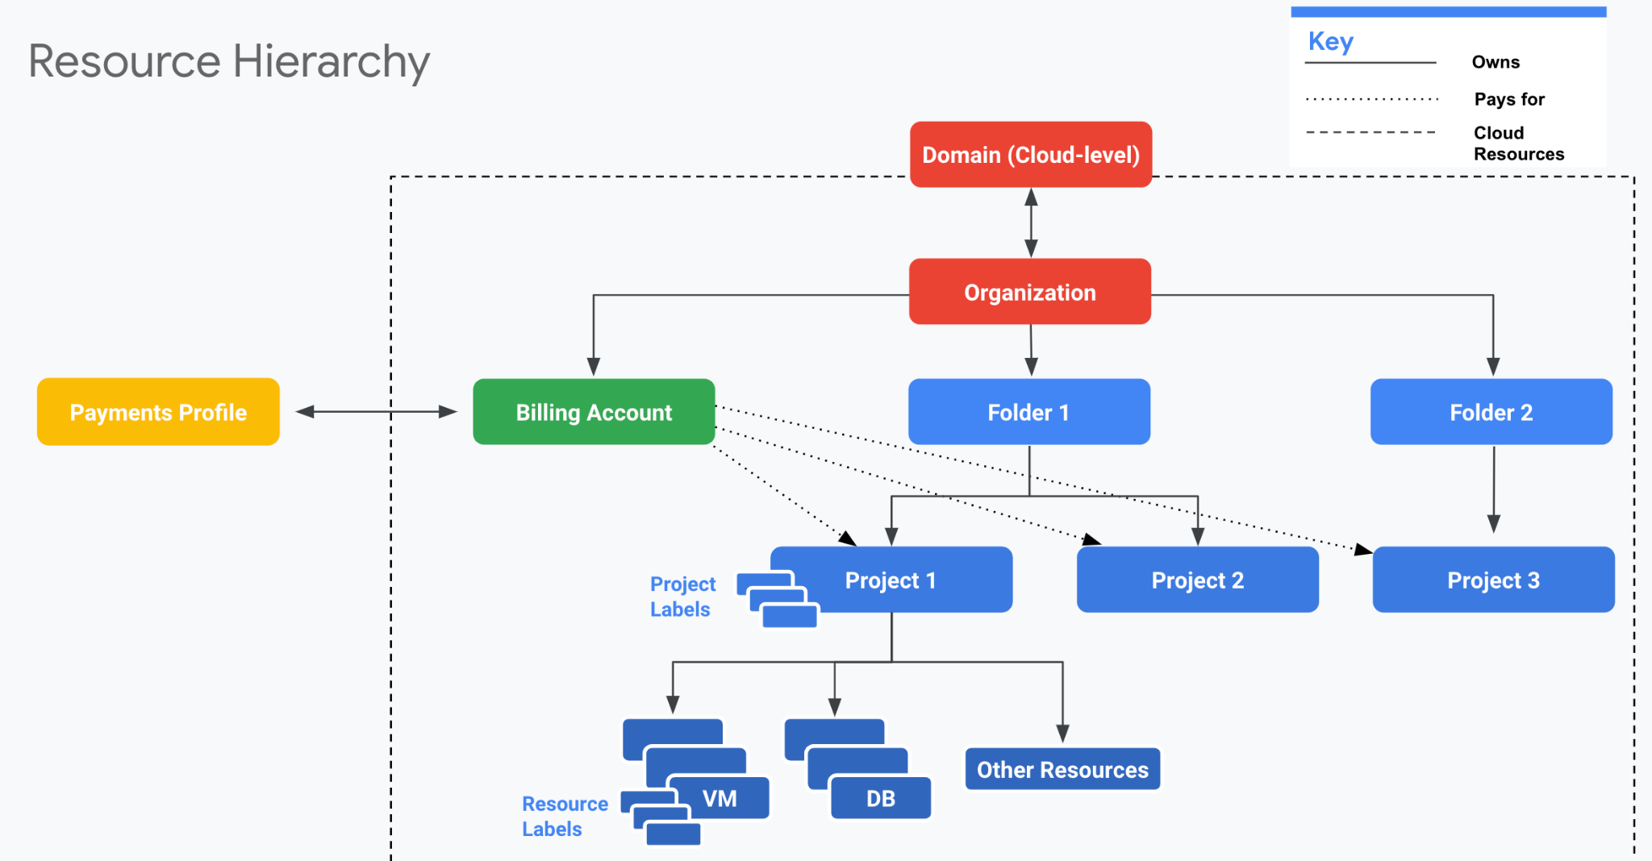

Access levels required in GCP enviormenent <https://cloud.google.com/billing/docs/how-to/billing-access>

**Note:** Other legacy roles (such as Project Owner) also confer some Cloud Billing permissions. The Project Owner role is a superset of Project Billing Manager.

----------------------------------------------------------------------------------------------------------------------------------------------------------------